## LIST OF CONTENTS

### CONTENTS PAGE NO

**CHAPTER 1: INTRODUCTION** 3-5

**1 General**

* 1. Concrete 3
  2. Waste brick powder 4
  3. Scope of Study 4
  4. Objectives 5
  5. Organization of thesis 5

**CHAPTER 2: LITERATURE SURVEY** 6-13

**CHAPTER 3: MATERIALS**  14-15

3.1 Mix Proportion 16 - 20

3.2 Test Conducted on Material 20 – 32

3.3 Tests conducted on Concrete 33 – 46

**CHAPTER 4: CONCLUSION** 47

**REFERENCES** 48-49

### LIST OF TABLES

### SL No Table Name Page No

### Test On Cement 21-22

### Test On Fine Aggregate 23-27

### Test On Coarse Aggregate 27-29

### Test On Brick Powder 30-32

### Test On Fresh Concrete 33-35

### Test On Hardened Concrete 36-46

CHAPTER-1

## INTRODUCTION

## 1. GENERAL

### 1.1 Concrete:

Concrete is defined as a mixture of sand, gravel and water which dries hard and strong & is used as a material for building. Concrete, usually **Ordinary** **Portland Cement Concrete**, is a composite material composed of fine and coarse aggregate bonded together with a fluid cement that hardens overtime most frequently in the past a lime-based cement binder, such as lime-putty, but sometimes with other hydraulic cements, such as calcium aluminates, cement or portable cement. It is distinguished from other non- cementitious types of concrete all binding some form of aggregate together, including asphalt concrete with a bitumen binder, which is frequently used for road surfaces, and polymer concrete that use polymers as a binder. Concrete is one of the oldest and most common construction materials in the world, mainly due to its low cost, availability, its long durability, and ability to sustain extreme weather environments. Concrete is a brittle material that has a high compressive strength, but a low tensile strength. Thus, reinforcement of concrete is required to allow it to handle tensile stresses.

**1.2 WASTE BRICK POWDER:**

Bricks are widely used construction and building material around the world. Bricks have been major construction and building material for a long time. The worldwide annual production of bricks is currently about 1391 billion units and the demand for bricks is expected to be continuously rising. Since the increasing demand on building materials in the last decade, the civil engineers have been in challenged to covert the industrial wastes into useful building and construction materials. Accumulation of unmanaged wastes especially at the developing countries as a result in an increase on environmental concern. Recycling of such wastes as building material appears to be viable solution not only to solve such pollution problem but also to the problem of economic design of buildings. The increase in popularity of using environmentally friendly and low cost construction materials in building industry has brought about the need to investigate how this can be achieved by benefiting to the environment as well as maintaining the material requirements affirmed in the standards.

**Brick powder** is obtained from the dust of disintegrated bricks also the waste bricks are obtained from garbage of a brokenbuilding. The collected waste bricks are pulverized to get the particle passing through 4.75-micron sieve to get the grading of fine aggregate for 15%, 25%, and 30% brick powder is used as replacement for fine aggregate in the experiments.

Brick dust occurs from loading or unloading, construction sites and brick kilns. This dust is used in dumping and filling. There are thousand Tons of brick waste generated each year around the world which goes in unplanned way. Pozzolanic materials such as brick dust and other ceramics powder has been used in concrete since ancient times. In ancient times the brick dust was used according to experiences and experiments as they were unaware of the properties of brick dust. Bricks are made up of different types of clays and other materials like sand. Clay composed up of 20-30% Alumina, 50-60% Silica, and other carbonates and oxides. The waste bricks used in this study were obtained from recycled bricks. Cracked pieces of bricks were crushed by a jaw crusher. And at laboratory scale the bricks wastes were ground with an air jet mill to obtain bricks powder. The resulting powders were sieved through a 45-µm (325 mesh) sieve. The chemical compositions of brick pastes were analyzed and results obtained.

**Bricks waste may come from two sources:** The first source is the bricks industry, and this waste is classified as non-hazardous industrial waste, the second source of bricks waste is associated with construction and demolition activity, and constitutes a significant fraction of construction and demolition waste. Therefore, the replacement of fine aggregate by bricks wastes has the advantage of solving several environmental problems.

## 1.3 SCOPE OF THE STUDY:

## The main focus of the research is to present additional information in the field of recycling clay masonry rubbles in order to explore the possible uses of these recyclable materials in structural applications. The current work concludes performance-based guidelines that are imperative from the cost and environmental aspects and that also can be recycled brick powder in concrete. Brick powder reduces weight of the concrete. With the increase in construction activities, there is heavy demand on concrete and consequently on its ingredient like aggregate also. So crushed brick waste has been used as an alternative to this demand.

* To use waste brick powder as a construction material.
* It will slightly reduce the dependency on natural sand or M sand.
* Its use will also help in protecting the environment surroundings.

## 1.4 OBJECTIVES:

The main objectives of present study are:

* To study the suitability of waste brick powder in concrete.
* To study the desirable properties of waste brick powder in concrete.
* To evaluate the utility of crushed brick as a partial replacement of sand in concrete.
* To understand the effectiveness of brick as in strength enhancement.

**1.5 ORGANIZATION OF THESIS:**

**Chapter 1** includes introduction to partial replacement of fine aggregate using brick powder. It also includes scope of the study and objectives of the study.

**Chapter 2** deals with the brief review of the available literature on partial replacement of fine aggregate using brick powder and appraisal of the reviewed literature is done.

**Chapter 3** gives an overview of materials used and tests are conducted.

**Chapter 4** deals with the methodology or procedure, involved in preparation of the concrete blocks and tests on Fresh and hardened concrete.

CHAPTER**-**2

## LITERATURE SURVEY

This chapter deals with the brief review of available literature on partial replacement of fine aggregate using waste brick powder and also about its relevant topics, to understand and analyze the latest methodologies adopted in the studies conducted by various authors.

**Farid Debieb (2007):**

recycling and reuse of building rubble present interesting possibilities for economy on waste disposal sites and conservation of natural resources. This paper examines the possibility of using crushed brick as coarse and fine aggregate for a new concrete. Either natural sand, coarse aggregates or both were partially replaced (25, 50, 75 and 100%) with crushed brick aggregates. Compressive and flexural strengths up to 90 days of age were compared with those of concrete made with natural aggregates. Porosity, water absorption, water permeability and shrinkage were also measured. The test results indicate that it is possible to manufacture concrete containing crushed bricks (coarse and fine) with characteristics similar to those of natural aggregates concrete provided that the percentage of recycled aggregates is limited to 25% and 50% for the coarse and fine aggregates, respectively.

**J. Martina Jenifer, et.al., (2016):**

Concrete is the most material being used in infrastructure development throughout the world. Sand is a prime material used for preparation of mortar and concrete and which plays a major role in mix design. Natural or River sand are weathered and worn-out particles of rocks and are of various grades or sizes depending upon the amount of wearing. Now-a-days good sand is not readily available, it is transported from a long distance. Those resources are also exhausting very rapidly. The non-availability or shortage of river sand will affect the construction industry, hence there is a need to find the new alternative material to replace the river sand, such that excess river erosion and harm to environment is prevented. Many researchers are finding different materials to replace sand. This study aimed to investigate the suitability of using crushed brick in concrete. Crushed brick originated from demolished masonry was crushed in the laboratory and added partial sand replacement. Three replacement levels, 15%,20% and 25%, were compared with the control. The tests on concrete showed that the mechanical properties (compressive, flexural and splitting tensile strengths) of concrete containing crushed brick were well comparable to those of the concrete without ground brick.

**Diniya David, et.al., (2017):**

Light weight concrete has tremendous advantages such as lower density and thermal insulation property and also strong enough to be used for structural purposes. Cellular concrete comes under the classification of this light weight concrete. Most important property of cellular concrete is low thermal conductivity. This property can be improved by decreasing the density. It will significantly reduce the dead load of structural elements. In this present experimental investigation, the cellular property is achieved by addition of aluminum metal powder in varied percentages such as 0.5, 1, 1.5, 2, 2.5, and 3%. Crushed clay brick is used as replacement of conventional fine aggregate with varied percentages such as 10, 20,23,25,27 and 30% in each percentage of cellular concrete. The cellular property is improved by increased addition of aluminum metal powder. The compressive strength will increase up to 25% replacement of crushed clay brick in cellular concrete. It is concluded that addition of 1% of aluminum metal powder along with varied crushed clay brick percentages, satisfy the lightweight property and compressive strength. From these experimental results we can say that this concrete belongs to structural light weight concrete.

**Shruthi H G, et.al., (2017):**

Concrete is the most important material being used in infrastructure development throughout the world. Sand is a prime material used for preparation of mortar and concrete and which plays a major role in mix design. Natural or River sand are weathered and worn out particles of rocks and are of various grades or sizes depending upon the amount of wearing. Now-a-days good sand is not readily available, it is transported from a long distance. Those resources are also exhausting very rapidly. The non-availability or shortage of river sand will affect the construction industry; hence there is a need to find the new alternative material to replace the river sand, such that excess river erosion and harm to environment is prevented. Many researchers are finding different materials to replace sand. This study aimed to investigate the suitability of using crushed brick in concrete. Crushed brick originated from demolished masonry was crushed in the laboratory and added partial sand replacement. Five replacement levels, 10%,20% ,30%,40%, 50%, were compared with the control. The tests on concrete showed that the mechanical properties (compressive strengths) of concrete containing crushed brick were well comparable to those of the concrete without ground brick.

**Awadhesh Chandramauli, et.al., (2018):**

India is a developing country. Developing infrastructure leads to consumption of concrete. Sand have big value in concrete. But natural sands are limited resources. River sand is most common fine aggregates in concrete. Due to excessive production of the river sand, it is banned by the government of India. Thus replacement of sand becomes need in last decays and the partially replacement will contribute to a good point to the research area. Number of researcher doing work on the replacement of sand by number of material like waste glass powder, crushed fir bricks and etc. Fire bricks are used to prevent the heat transfer in industries, lining furnace and fire places. The waste material of fire bricks can be used as fine aggregates. Properties of fire bricks are increases the strength of concrete. This research able to reduce the dependency on sand and open a new option to dispose of waste fire bricks. Partial replacement is done at 0%, 22%, 25%, 28% and 31% in this project. The test result says the 28% replacement gives the maximum tensile strength.

**R. Veerakumar, (2018):**

Concrete is the most material being used in infrastructure development throughout the world. Fine aggregate is a prime material used for preparation of mortar and concrete and which plays a major role in mix design. Fine aggregates are weathered and worn out particles of rocks and are of various grades or sizes depending upon the amount of wearing. Now-adays fine aggregate is not readily available, it is transported from a long distance. Those resources are also exhausting very rapidly. The non-availability or shortage of fine aggregate will affect the construction industry, hence there is a need to find the new alternative material to replace the fine aggregate, such that harm to environment is prevented. Many researchers are finding different materials to replace fine aggregate. This study aimed to investigate the suitability of using brick debris in concrete in place of fine aggregate. Brick debris originated from demolished masonry walls crushed in the laboratory and added in partial fine aggregate replacement. Four replacement levels, 5%, 10%, 15%, and 20%, were compared with the control. The tests on concrete showed that the mechanical properties (compressive strength test) of concrete containing brick debris were well comparable to those of the concrete without ground brick.

**Awadhesh Chandramauli, et.al., (2018):**

Developing infrastructure leads to consumption of concrete. Sand have big value in concrete. But natural sands are limited resources. River sand is most common fine aggregates in concrete. Due to excessive production of the river sand, it is banned by the government of India. Thus replacement of sand becomes need in last decays and the partially replacement will contribute to a good point to the research area. Number of researchers doing work on the replacement of sand by number of materials like waste glass powder, crushed fir bricks and etc. Fire bricks are used to prevent the heat transfer in industries, lining furnace and fireplaces. The waste material of fire bricks can be used as fine aggregates. Properties of fire bricks are increasing the strength of concrete. This research able to reduce the dependency on sand and open a new option to dispose of waste fire bricks. Partial replacement is done at 0%, 22%, 25%, 28% and 31% in this project. The test result says the 28% replacement gives the maximum tensile strength.

**Juntao Dang, et.al., (2018):**

In order to solve the problem existing in the utilization of fine recycled aggregates from crushed bricks (RCBA), the replacement of natural fine aggregate (NA) by RCBA to produce a new green recycled mortar is an important technology to develop renewable resource products and realize waste resources recycling. In this paper, in order to deeply understand the mechanism of RCBA, macroscopic and microscopic tests are carried out to study the influence of RCBA with different replacement ratios, particle sizes and additional water contents on the flow ability, compressive strength and flexural strength of mortar. And the physical properties, chemical composition, mineral composition and microscopic morphology of RCBA are analyzed. The results show that the porous structure of the waste clay bricks together with the secondary mechanical crushing treatment result in the decline of the physical properties of RCBA. The fully additional water content in RCBA is beneficial to improve the flow ability of mortar, but the partially additional water content in RCBA has an adverse impact. In addition, the RCBA with partially additional water content and particle size of 0–5 mm is beneficial to the improvement of mortar strength. However, the RCBA with fully additional water content and particle size of 0.15–5 mm is detrimental to the development of mortar strength. The microscopic test indicates the rough surface and pozzolanic activity of RCBA produce relatively stable and dense interfacial transition zone between the RCBA and cement paste.

**Anayat Ali, et.al., (2019):**

The widely used material in infrastructure development and construction throughout the world is concrete and mortar. A significant role in the mix design is played by fine aggregate and coarse aggregate which are the prime material used for the preparation of mortar and concrete. River sand is becoming a scarce commodity nowadays. Hence the manufactured sand is playing a major role in the construction industry nowadays. The natural resources due to excessive use are also exhausting very rapidly. Shortage of fine and coarse aggregate may affect construction industry directly, therefore there is a need to find an alternative material which can replace fine aggregate or coarse aggregate fully or partially so that the damage due to excessive erosion to the environment is prevented. Thus, the replacement of fine aggregate and coarse aggregate became a necessity in the recent times and this partial or complete replacement will contribute a lot to nature and environmental problems created due to excessive use and dumping of brick debris or construction waste. This research review will discuss the partial replacement of fine aggregate with brick dust and how to reduce the dependency on the natural resources such as sand used as fine aggregate and provide a new way to dispose of waste brick debris. Different replacement levels 10%, 15%, and 20%, will be checked. Different tests showed that the compressive strength is enhanced by using optimum percentage replacement of natural fine aggregate with brick debris compared to conventional mortar and concrete.

**Khairunisa Muthusamy, et.al., (2020):**

Environmental pollution caused by disposal of by-product from local industries namely fly ash from coal power plant and palm oil clinker generated by palm oil mills needs to be resolved. This research examines the effect of palm oil clinker as partial sand replacement on properties of fly ash cement sand brick. Five brick mixes were prepared using fly ash blended cement as the binder. Other mixes were produced by varying the quantity of pulverized palm oil clinker ranging from 0%, 10%, 20%, 30% and 40% by weight of sand. All specimens were water cured for 28 days. The specimens were subjected to compressive strength, flexural strength and water absorption test. Utilization optimum amount of clinker of 30% enhances the brick strength owing to the pozzolanic effect of fine clinker. The chemical reaction between calcium hydroxide and silicon dioxide forms extra CSH gel that contributes to pore refinement and higher strength of brick.

**S.M. Basutkar, et.al., (2020):**

With the evolvement of construction practices, Construction and Demolition (C and D) waste disposal is of greater concern as it poses negative impact on the environment. Major constituents of C and D waste are concrete and masonry accounting up to 60%. In this present investigation, paver blocks for pedestrian traffic are produced using C and D brick waste aggregates as a replacement for fine aggregates (MSand). The crushed brick masonry waste (fine aggregates between 150m and 4.75 mm) was used as replacement for fine aggregates at 25%, 50% and 75%. The fines content (fine aggregates < 150m) in the mix composition were varied at 10%, 20% and 30%. The compressive strength test for Recycled Aggregate Paver Blocks (RAPB) was evaluated at 7, 14, 21, 28 and 90 days of curing. Flexural strength and water absorption tests were also performed on RAPB. It was observed that brick masonry waste aggregates with 25% and 50% replacement for conventional fine aggregates is adoptable with no compromise of desired compressive strength value. The percentage replacement can be increased to 75% provided that the fines content is limited to 10%. Replacement of conventional fine aggregates by brick waste by 50% can be adopted in making RAPB as it leads to greater utilization of C and D waste and also provides flexibility in the presence of percentage fines content i.e., up to 30% fines content can be present. The control of fines content in the RAPB mix, aids in better packing of concrete. Variation in the density of paver blocks was found to be

**Juntao Dang, et.al., (2020):**

To tackle the shortage of natural sand and to reduce the construction waste from clay bricks, the use of recycled bricks to replace sand as fine aggregates to produce more sustainable concrete is explored. This paper studied the effect of replacement levels of sand aggregates (SA) by recycled brick aggregates (RBA) at 0%, 50%, and 100%, and the additional water included in the mix proportion to represent the different moisture states of RBA (oven-dry, partial-dry, saturated-surface-dry) on the microstructure and durability of the concrete. The results show that the replacement of SA by RBA reduces the chloride migration but increases the water absorption, water sorptivity, drying shrinkage and carbonation. The water absorption, water sorptivity and carbonation can be minimized by reducing the additional water content. The microscopy results show that the pore structure of concrete deteriorates with the increase in the replacement because of the porous structure of RBA. Due to the pozzolanic reactivity of the RBA, the Ca(OH)2 crystals in concrete were consumed to generate hydration products, resulting in denser interfacial transition zone and enhanced adhesion between the RBA and the cement matrix.

**Mane Rainia, et.al., (2020):**

Construction and demolition waste (CDW) valorization in a new production process has been widely studied. However, up to now, valorization has been limited to use one type of waste. Hence, the environmental and economic benefits remain quite narrow, particularly in countries with high waste production. This paper aims to determine the feasibility of using waste from rejected concrete specimens by civil engineering laboratories combined with waste brick, as an alternative of natural fine aggregate in the production of cement mortar. Natural fine aggregate (NFA) has been replaced by recycled fine aggregate (RFA), at 0%, 15 %, 30 %, 45 %, and 90 %, by weight. In this study, RFA from concrete and brick wastes were firstly characterized and compared to the NFA. Then several tests were carried out in order to evaluate the effect of RFA on mortars. The RFA’ physical, mineralogical and microstructural properties prove to be different from those of NFA. Nevertheless, the results have shown that the incorporation of these RFA at 15 % do not have any negative effect on the mechanical performance of the mortars. Besides, the microscopic analysis has revealed that the addition of RFA doesn’t compromise the microstructural properties of the mortars at low substitution rates. As a whole, this study shows that the use of RFA is possible.

**Qian Huang, et.al., (2020):**

The waste clay brick (WCB) was crushed and used as the fine aggregates to produce recycled mortars with sufficient workability (i.e. high water-cement ratio of 0.6). Two curing conditions (air and standard) and two statuses of WCB (dry and pre-soaking) were considered in this study. It was found that the recycled mortars with the dry WCB had relatively higher mechanical properties and lower water absorption but a converse tendency for pre-soaking WCB mortars, regardless of the curing conditions. Although the internal curing effect of WCB was more pronounced under the air condition, the overall performance of recycled mortars cured in the standard condition was better. Microstructural changes were then investigated through X-ray diffraction (XRD), thermos gravimetric-differential scanning calorimetry (TG-DSC), scanning electron microscopy (SEM), and mercury intrusion porosimeter (MIP) to support the macro property changes of recycled mortars. As evaluated by TG-DSC, the hydration degree of cement in the recycled mortar with dry WCB were greater than that of reference group without WCB, and the hydration degree further increased when the natural aggregates were replaced by the pre-soaking WCB. Regardless of the curing conditions, the WCB aggregate were tightly bonded by cement paste in the recycled mortar with dry WCB, and the interfacial transition zone (ITZ) between them was more compact. Conversely, the interval between pre-soaking WCB and cement matrix was observed. The incorporation of dry or pre-soaking WCB increased the porosity of recycled mortars. The recycled WCB mortars could be used for producing the cleaner building materials.

**Arivalagan, et.al., (2021):**

Concrete is the most widely used construction material today. The constituents of concrete are coarse aggregate, fine aggregate, coarse aggregate and water. Concrete plays a major role in the construction industry and a large quantum of concrete is being utilized. River sand, which is one of the constituents used in the production of conventional concrete, has become expensive and also a scarce material. In view of this, the utilization of demolished aggregate which Isa waste material has been accepted as building material in many countries for the past three decades. The demand of natural sand in the construction industry has increased a lot resulting in the reduction of sources and an increase in price. Thus an increased need to identify a suitable alternative material from industrial waste in place of river sand, that is eco-friendly and inexpensive construction debris i.e. fresh concrete being extensively used as an alternative to the sand in the production of concrete. There is an increase in need to find new alternative materials to replace river sand so that excess river erosion is prevented and high strength concrete is obtained at lower cost. One such material is building construction debris: a by-product obtained during construction and demolition waste. An experimental investigation is carried out on M25 concrete containing debris during construction in the different range of 20%, 30% & 40% by weight of sand. Material was produced, tested and compared with conventional concrete in terms of workability and strength. These tests were carried out on standard cube of 150×150×150 mm and beam of 700×150×150 mm for 28 days to determine the mechanical properties of concrete.

**CONCLUSION OF LITERATURE REVIEW:**

A comprehensive review of literature covering papers from Journals and conferences was carried out: papers reviewed were predominantly based on Waste brick powder. The literature review indicates that very few publications are available on the waste brick powder, Variables aspect ratio such as, different grades of concretes and different percentages of brick powder are simultaneously covered in papers reviewed. Therefore, there is requirement for the study both compressive strength and Flexural strength of concrete preparing using waste brick powder as a partial replacement of fine aggregate.

CHAPTER-3

## MATERIALS

* 1. **CEMENT:** 53 Grade ordinary Portland cement conforming to IS 12269.

A cement is a binder, a substance used for construction that sets, hardens, and adheres to other materials to bind them together. Cement is seldom used on its own, but rather to bind sand and gravel (aggregate) together. Cement mixed with fine aggregate produces mortar for masonry, or with sand and gravel, produces concrete. Concrete is the most widely used material in existence and is behind only water as the planet's most-consumed resource.

### AGGREGATE

* + 1. **Coarse Aggregate** - 20mm size

Coarse aggregates refer to irregular and granular materials such as gravel, or crushed stone, and are used for making concrete. In most cases, Coarse is naturally occurring and can be obtained by blasting quarries or crushing them by hand or crushers.

* + 1. **Fine Aggregate** - Passing through 4.75mm sieve.

A good concrete mix must include aggregates that are clean, hard, strong and free of absorbed chemicals or coatings of clay and other fine materials. Ignorance of these characteristics can cause the deterioration of concrete, thus regulatory authorities have decided grading zone of fine aggregate**,**where each zone defines the percentage of fine aggregate passed from the 600 microns’ sieve size.

* 1. **Waste Brick powder:** Bricks are widely used construction and building material around the world. Brick powder is obtained from the dust of disintegrated bricks also the waste bricks are obtained from garbage of a broken building. The collected waste bricks are pulverized to get the particle passing through 4.75-micron sieve to get the grading of fine aggregate 15, 25, and 30, 40, 50% brick powder is used as partial replacement as fine aggregate in the experiments. The waste bricks used in this study were obtained from recycled bricks. Cracked pieces of bricks were crushed by a jaw crusher. And at laboratory scale the bricks wastes were ground with an air jet mill to obtain bricks powder. The resulting powders were sieved through a 4.75-µm (325 mesh) sieve. The chemical compositions of brick pastes were analyzed and results obtained.

**3.4 MIX PROPORTON OF CONCRETE**

* The mix proportion is designed for M25 concrete conforming IS codes.
* **Concrete Mix Design for M – 25 Grade of Concrete**

**STEP-1 STIPULATION FOR PROPORTIONING**

* Grade= M25
* Type of cement= OPC 53 Grade
* Max. size of aggregate= 20mm
* Min. cement content and max. water cement ratio = Moderate (IS-456 Table 9)
* Workability= 100mm Slump
* Method of placing = non-pumpable
* Type of aggregate= crushed angular
* Fine aggregate= Zone – 2
* **STEP-2 TEST DATA**
* Specific gravity of cement= 3.16
* Specific gravity of coarse aggregate= 2.88
* Specific gravity of fine aggregate= 2.60
* Water absorption for FA & CA= 1.01% & 0.65%
* Specific gravity of water **=** 1
* **STEP-3 TARGET STRENGTH**

f’ck = fck+1.65(S) (where S=4)

= 31.6 N/mm2

  f’ck = fck+**x**

(Where **x**= 5.5)

= 30.5 N/mm2 (Therefore take maximum value)

* Air content for 20mm CA = 1%
* W/C ratio 0.5

Therefore, **f’ck= 31.6N/mm2**

* **STEP**-**4 WATER CEMENT RATIO**

0.5 (AS PER IS:456 TABLE 5)

* **STEP**-**5 SELECTION OF WATER CEMENT RATIO**

For 20MM aggregate – 186 kg for (50 mm slump)

For every 25mm add 3%

186+6% of 186

= 197.16 kg

* **STEP**-**6 CALCULATION OF CEMENT CONTENT**

W/C RATIO = W/C

C = W/(W/C)

= 197/0.5

= 394 kg/m3 > 300 kg /m3

* **STEP**-**7 Proportion Between Coarse Aggregate and Fine Aggregate**

IS- 10262 Table – 5 (1.5.5.1)

Zone 2 = 0.62 (For w/c = 0.5)

Volume of coarse aggregate = 0.62m

Volume of fine aggregate = 1 -0.62 = 0.38m3

* **STEP**-**8 Mix calculation**

Total volume=1m3

Volume of entrapped air **=** 0.01m3

Volume of cement = mass of cement/sp. Gravity (1/1000)

= 394/3.10=0.124m3

Volume of water = mass of water/sp. Gravity water

= 197/1000=0.197m3

Volume of all aggregate = (1-0.01) + (0.124+0.197)

= 0.669m3

Mass of CA = E*vol. of CA*Sp. of CA*1000

= 0.669*0.62*2.88*1000

=1194.54kg

Mass of FA = E*vol. of FA*Sp. of FA*1000

= 0.669*0.38*2.60*1000

= 660.97kg

* **STEP-9 Mix proportion**

Cement = 394kg/m3

Water = 197.16kg/m3

Fine aggregate = 660.92kg/m3

Coarse aggregate = 1194.54kg/m3

W/C ratio = 0.50

**The Extra Water to Be Added for Absorption by Coarse Aggregate and Fine Aggregate**

* **For Fine Aggregate:** -

Mass of FA = Mass of fine aggregate/ (1+ water ratio/100)

= 660.97 / (1+1.01/100)

= 654.36 kg/m3

* **For Coarse aggregate: -**

Mass of CA = mass of coarse aggregate/ (1+water ratio/100)

= 1186.82 kg/m3

1. Fine Aggregate

= 660.97 -654.36 = 6.61 Kg

2. Coarse aggregate

= 1194.54 – 1186.82 = 7.72 Kg

Water to be added = 197.16+6.61+7.72 = 211.49kg

* **Mix Proportion After Adjustment**

Cement= 394kg/m3

Water (to be added) = 211.49 kg/m3

Fine aggregate (dry) = 654.36kg/m3

Coarse aggregate(dry) = 1186.82 kg/m3

Water cement ratio = 0.5

* **TRAIL 2**

Increase the 10% of water

water cement ratio =0.6

* **STEP- 1 CALCULATION OF CEMENT CONTENT**

W/C RATIO = W/C

C = W/(W/C)

= 197/0.6

= 328.6 kg/m3 > 300 kg /m3

* **STEP-2 PROPORTION BETWEEN CA AND FA**

IS- 10262 Table – 5 (1.5.5.1)

Zone 2 = 0.62

Volume of coarse aggregate = 0.62

Volume of fine aggregate = 1 -0.62 = 0.38m3

* **STEP-3 Mix calculation**

Total volume=1m3

Volume of entrapped air **=**0.01m3

Volume of cement = mass of cement/sp. Gravity (1/1000)

= 328.6/3.10=0.103m3

Volume of water = mass of water/sp. Gravity water

= 197/1000=0.197m3

Volume of all aggregate = (1-0.01) + (0.103+0.197)

= 0.69m3

Mass of CA = E*vol. of CA*Sp. of CA*1000

= 0.69*0.62*2.88*1000

=1232.06.54kg

Mass of FA = E*vol. of FA*Sp. of FA*1000

= 0.69*0.38*2.60*1000

=681.72kg

* **Step-4 mix proportion**

Cement = 328.6kg/m3

Water = 197.16kg/m3

Fine aggregate = 681.72kg/m3

Coarse aggregate = 1232.06kg/m

W/C ratio = 0.60

**The Extra Water to Be Added for Absorption by Coarse Aggregate and Fine Aggregate**

* **For Fine Aggregate:** -

Mass of FA = Mass of fine aggregate/ (1+ water ratio/100)

= 681.72 / (1+1.01/100)

= 674.90 kg/m3

* **For Coarse aggregate: -**

Mass of CA = mass of coarse aggregate/ (1+water ratio/100)

= 1224.05 kg/m3

1. Fine Aggregate

=681.72 -674.90 = 6.82 Kg

2. Coarse aggregate

= 1232.06 – 1224.05 = 8.01 Kg

Water to be added = 197.16+6.82+8.01 = 211.99kg

* **Mix Proportion After Adjustment**

Cement= 328kg/m3

Water (to be added) = 211.99 kg/m3

Fine aggregate (dry) = 674.90kg/m3

Coarse aggregate(dry) = 1224.05 kg/m3

Water cement ratio = 0.60

**TESTS CONDUCTED ON MATERIALS**

* **CEMENT**
* Normal consistency.
* Specific gravity.

* **FINE AGGREGATE**
* Fineness modulus and zoning.
* Specific gravity.
* Bulk density of fine aggregate
* **COARSE AGGREGATE**
* Fineness modulus and grading.
* Specific gravity.
* Flakiness & Elongation.
* **BRICK POWDER**
* Fineness modulus and zoning.
* Specific gravity.

**TESTS CONDUCTED ON CEMENT**

**CEMENT: -** A cement is a binder, a substance used for construction that sets, hardens, and adheres to other materials to bind them together. Cement mixed with fine aggregate produces mortar for masonry, or with sand and gravel, produces concrete.

* 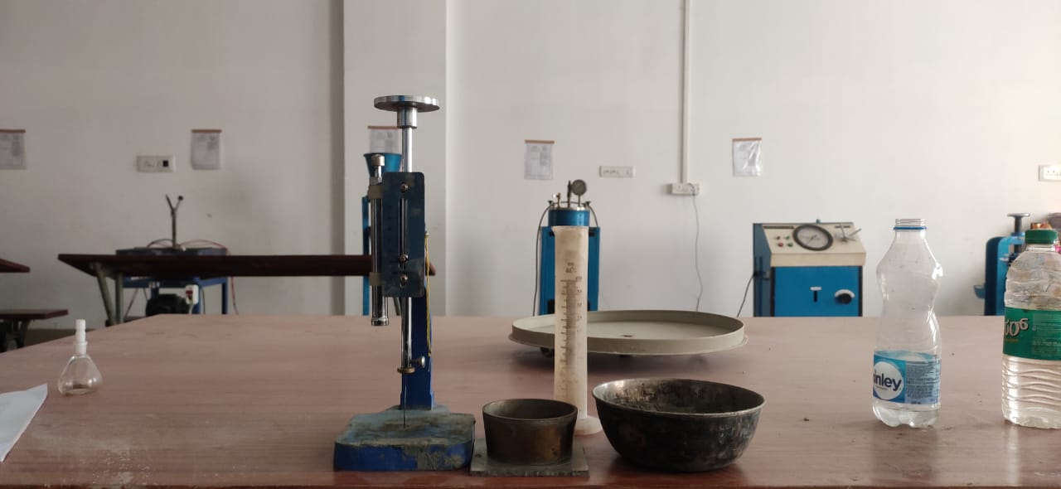**NORMAL CONSISTENCY**: - The purpose of conducting this test is to find the amount of water to be added to the cement to get a normal consistency. The result obtained from this test is used to fix the quantity of water to be mixed in cement before conforming test for tensile strength, sitting time & soundness.

**Fig 3.1: CONSISTENCY**

**Weight of cement taken = 300 gm**

|  |  |  |  |  |  |
| --- | --- | --- | --- | --- | --- |
| **Trial** | **Water**  **(%)** | **Water**  **(ml)** | **Initial reading**  **(mm)** | **Final reading**  **(mm)** | **Percentage of**  **Plunger** |
| 01 | 27 | 100 | 41 | 38 | 4 |
| 02 | 29 | 104 | 41 | 36 | 5 |
| 03 | 30 | 112 | 41 | 16 | 15 |
| 04 | 31 | 116 | 41 | 12 | 19 |
| 05 | 32 | 120 | 41 | 06 | 32 |

**PENETRATION= 32%**

**AS PER IS CODES THE STANDERED VALUE OF CONSISTENCY OF CEMENT IS BETWEEN 31% TO 35%**

* **SPECIFIC GRAVITY OF CEMENT**

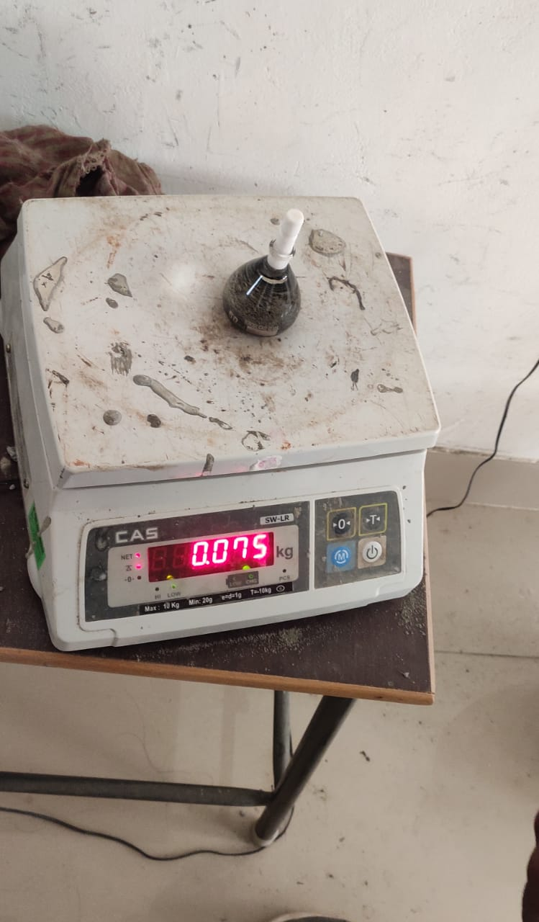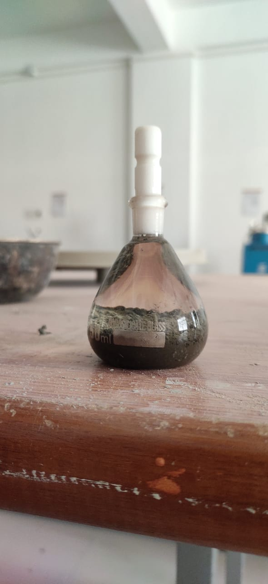The specific gravity of cement is the ratio of the weight of a given volume of substance to the weight of an equal volume of water. To find the specific gravity of cement, it is required to find the weight of a certain volume cement and the weight of an equal volume of water. As cement reacts with water its specific gravity is determined with reference to a non-reactive liquid like kerosene.

**Fig 3.2: SPECIFIC GRAVITY OF CEMENT**

**OBSERVATION: -**

Wt. of cement taken W = 25 gm.

**TABULAR COLUMN: -**

|  |  |  |  |  |
| --- | --- | --- | --- | --- |
| **Sl no** | **Empty weight of density bottle (W1)** | **Weight of bottle + cement**  **(W2)** | **Weight of bottle + cement+ kerosene**  **(W3)** | **Weight of bottle + kerosene**  **(W4)** |
| 01 | 25 | 44 | 75 | 61 |

**FORMULA: -**

Specific gravity = W2-W1/(W2-W1) -(W3-W4)

= (44 - 25) / (44 - 25) -(75 -61)

= 3.16

**RESULT: -** Specific gravity of cement = 3.16

**AS PER INDIAN STANDERD CODES THE SPECIFIC GRAVITY OF CEMENT SHOULD BE NEARLY 3.15 IN THE ABOVE CASE WE GOT 3.15 HENCE IT IS SATISFIED.**

**TESTS ON FINE AGGREGATE**

* **GRADATION OF FINE AGGREGATE**

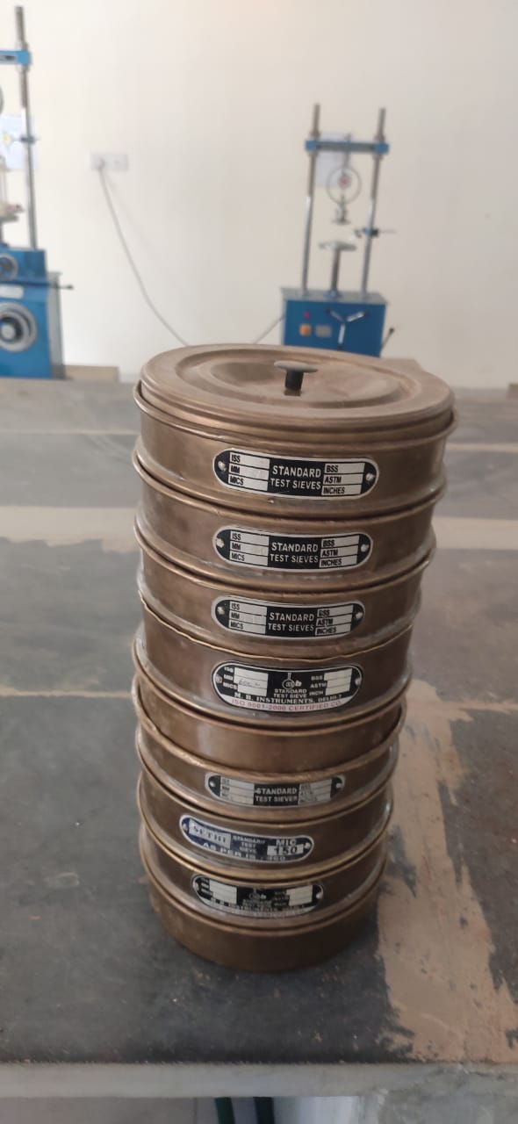Very fine size particles are not desirable in high percentage from strength point of view. Therefore, fine aggregates should be taken in suitable proportion of course to medium to fine particle sizes. Sieve analysis is carried out to ascertain the gradients of particle size distribution.

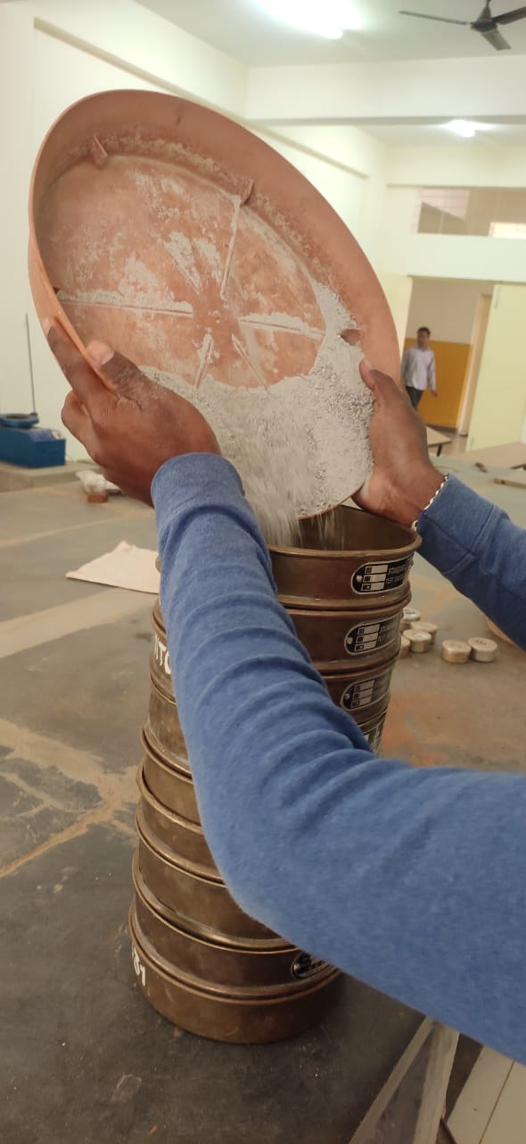**Fig 3.3: GRADATION OF FINE AGGREGATE**

* **TABULAR COLIUMN**

|  |  |  |  |  |  |
| --- | --- | --- | --- | --- | --- |
| **Sl no** | **IS Sieve**  **(mm, µ)** | **Weight**  **Retained (gm)** | **Cumulative**  **Weight**  **Retained(gm)** | **Cumulative**  **Retained (%)** | **Cumulative**  **Passing (%)** |
| 1 | 4.75 | 0 | 0 | 0 | 100 |
| 2 | 2.36 | 75 | 7.5 | 7.5 | 92.5 |
| 3 | 1.18 | 227 | 22.7 | 30.2 | 69.8 |
| 4 | 600 | 172 | 17.2 | 47.4 | 52.6 |
| 5 | 425 | 154 | 15.4 | 62.8 | 37.2 |
| 6 | 300 | 30 | 3 | 65.8 | 34.2 |
| 7 | 150 | 215 | 21.5 | 87.3 | 12.7 |
| 8 | 75 | 102 | 10.2 | 97.5 | 2.5 |
| 9 | Pan | 25 | 2.5 | 100 | 0 |

**Fineness modulus ∑ = (cum retained%) / 100**

**Fineness modules of fine aggregate = 2.75**

**AS PER INDIAN CODES THE GRADATION OF FINE AGGREGATE SHOULD BE BETWEEN 2.2 – 3.2**

* **SPECIFIC GRAVITY**

The specific gravity of fine aggregate is the ratio of the weight of a given volume of substance to the weight of an equal volume of water. To find the specific gravity of fine aggregate, it is required to find the weight of a certain volume fine aggregate and the weight of an equal volume of water.

**TABULAR COLUMN: -**

|  |  |  |  |  |
| --- | --- | --- | --- | --- |
|  | **Weight (gm)** | **Trial 1** | **Trial 2** | **Trial 3** |
| 1 | Weight of empty  Pycnometer(W1) | 661 | 661 | 661 |
| 2 | Weight of empty  Pycnometer + FA (W2) | 1066 | 1075 | 1062 |
| 3 | Weight of empty  Pycnometer + FA + water (W3) | 1785 | 1797 | 1790 |
| 4 | Weight of empty  Pycnometer + water (W4) | 1540 | 1540 | 1540 |
| 5 | Specific gravity | 2.53 | 2.63 | 2.65 |

* Specific gravity of fine aggregate = ( W2-W1)

(W2-W1) – (W3-W4)

1067-661

(1067-661) – (1790-1540)

**= 2.71**

**AS PER IS CODES THE SPECIFIC GRAVITY OF FINE AGGREGATE SHOULD BE BETWEEN 2.60 - 2.80**

* **BULKING OF FINE AGGREGATE**

When dry comes into contact with moisture, thin film is formed around the particles which causes them to get apart from each other. This will result in increasing volume of the sand. This phenomenon is known as bulking of sand. For this reason, if sand is measured by volume, bulking should be properly accounted.

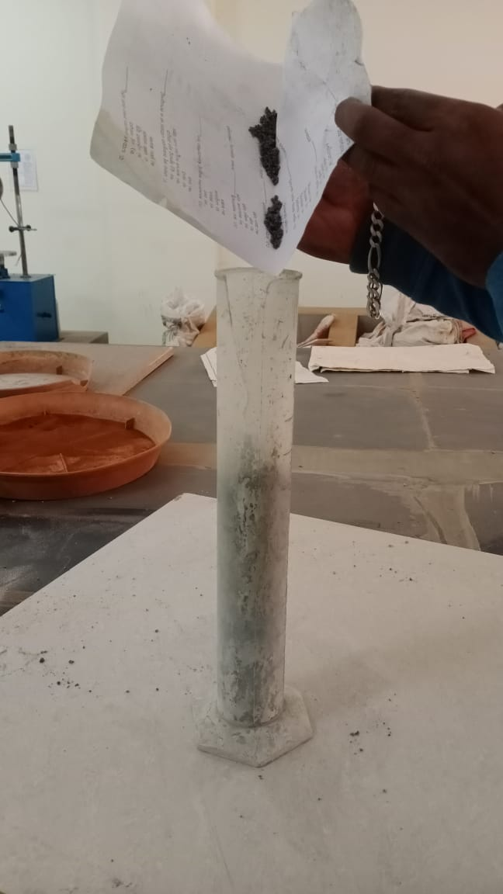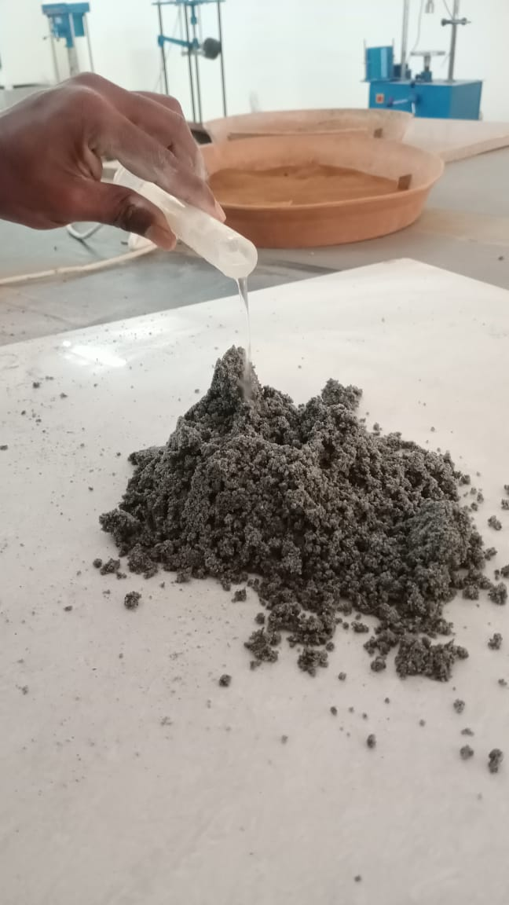**Fig 3.4: Bulking of Fine Aggregate**

* **Weight of fine aggregate= 500gm**
* **Initial height of sand H1= 300mm**

**TABULAR COLUMN: -**

|  |  |  |  |  |
| --- | --- | --- | --- | --- |
| **Sl No.** | **% OF WATER** | **Volume Of Water in ml** | **Height Of Sand**  **in mm** | **PAGE BULKING**  **(H2 -H1) / H1 *100** |
| 1 | 2 | 10 | 375 | 25 |
| 2 | 2 | 10 | 390 | 30 |
| 3 | 2 | 10 | 410 | 36 |
| 4 | 2 | 10 | 440 | 46 |
| 5 | 2 | 10 | 390 | 30 |
| 6 | 2 | 10 | 345 | 15 |

**FORMULA: -**

Bulking = ((H2 - H1) / H1) * 100

= ((440-300) /300) *100

= 46%

**RESULT: -**

Maximum bulking of fine aggregate is **46%**

**TESTS CONDUCTED ON COARSE AGGREGATE**

* Gradation of Coarse Aggregate
* Water absorption
* **GRADATION OF COARSE AGGREGATE**

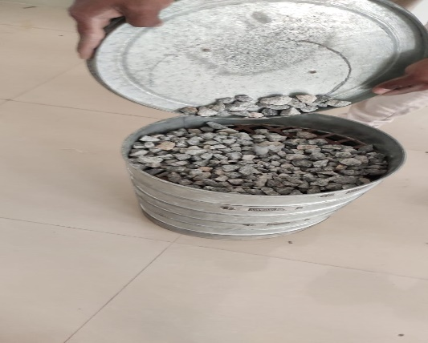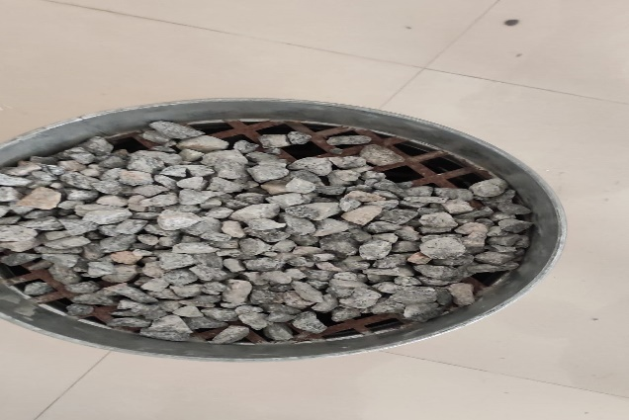Fineness modulus of coarse aggregates represents the average size of the particles in the coarse aggregate by an index number. It is calculated by performing sieve analysis with standard sieves. Higher the aggregate size higher the Fineness modulus hence fineness modulus of coarse aggregate is higher than fine aggregate.

**Fig 3.5: Gradation of Coarse Aggregate**

**Weight of aggregate = 3 kg.**

|  |  |  |  |  |  |
| --- | --- | --- | --- | --- | --- |
| **SI no** | **IS Sieve (mm, µ)** | **Weight**  **Retained(gm)** | **Cumulative**  **Weight**  **Retained(gm)** | **Cumulative**  **Retained (%)** | **Cumulative**  **Passing (%)**  ∑C=100-C4 |
| **1** | **80** | 0 | 0 | 0 | **100** |
| **2** | **40** | 0 | 0 | 0 | **100** |
| **3** | **20** | 91 | 3.03 | 3 | **97** |
| **4** | **16** | 1000 | 33.33 | 36 | **64** |
| **5** | **12.5** | 1286 | 42.86 | 78.86 | **21.14** |
| **6** | **10** | 441 | 14.7 | 93.56 | **6.44** |
| **7** | **6.3** | 102 | 3.4 | 96.96 | **3.04** |
| **8** | **4.75** | 60 | 2 | 98.96 | **1.04** |
|  | **Pan** | 20 | 0.6 | 99.56 | **0.44** |

Fineness modulus of coarse aggregate **=** (excluding C for pan) = ∑C/100 = 710/100=7.1

**FROM ABOVE IT IS CONCLUDED THAT THE COARSE AGGREGATE BELONGS TO ZONE – 2**

* **WATER ABSORPTION TEST ON COARSE AGGREGATE**

Specific gravity is defined as the ratio of the weight of a given volume of aggregate to weight of an equal volume of water. The specific gravity shows the strength and quality of the material. Aggregates with low specific gravity values indicates that it is having less strength.

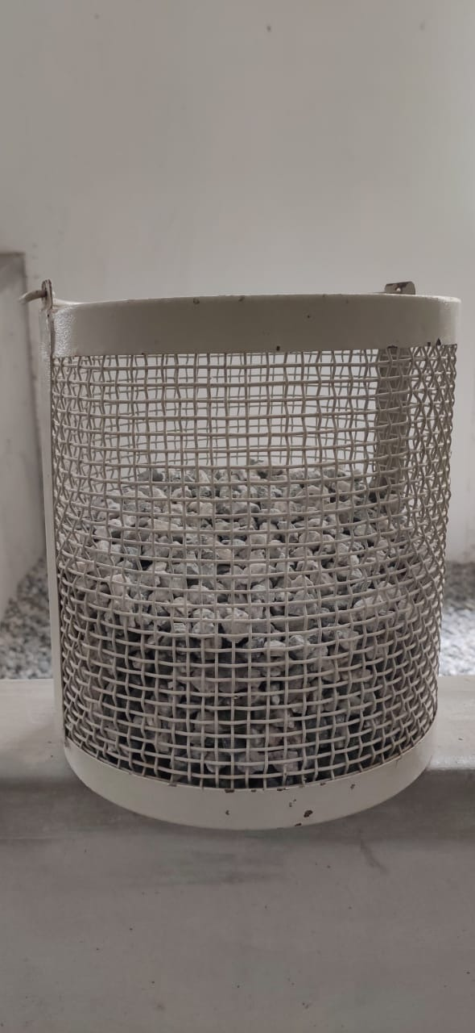

**Fig 3.6: water absorption of CA**

* **TABULAR COLUMN:**

|  |  |  |
| --- | --- | --- |
| **SI no** | **Weight (gm)** | **Trial 1** |
| 1 | Weight of saturated surface-dried sample in grams | 2419 |
| 2 | Weight of oven dried sample in grams | 2404 |
| 5 | Water absorption % | 0.62 |

**RESULT**: - water absorption value 0.62%

**TESTS CONDUCTED ON BRICK POWDER**

* Gradation of brick powder
* Specific gravity
* **GRADATION OF BRICK POWDER**

Fineness modulus of brick powder represents the average size of the particles in the waste brick powder by an index number. It is calculated by performing sieve analysis with standard sieves. Higher the aggregate size higher the Fineness modulus hence fineness modulus of waste brick powder is higher than fine aggregate.

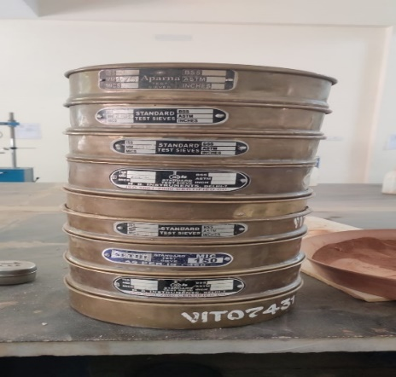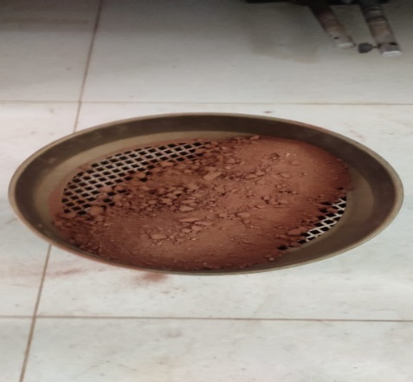 **Weight of aggregate = 1 kg**

**Fig 3.7: GRADATION OF BRICK POWDER**

|  |  |  |  |  |  |
| --- | --- | --- | --- | --- | --- |
| **Sl no** | **IS Sieve (mm, µ)** | **Weight**  **Retained (gm)** | **Cumulative**  **Weight**  **Retained(gm)** | **Cumulative**  **Retained (%)** | **Cumulative**  **Passing (%)** |
| **1** | **4.75** | 28 | 2.8 | 2.8 | 97.2 |
| **2** | **2.36** | 94 | 9.4 | 12.2 | 87.8 |
| **3** | **1.17** | 117 | 11.7 | 23.9 | 76.1 |
| **4** | **600** | 127 | 12.7 | 36.6 | 63.4 |
| **5** | **425** | 156 | 15.6 | 52.2 | 47.8 |
| **6** | **300** | 33 | 3.3 | 55.2 | 44.5 |
| **7** | **150** | 237 | 23.7 | 72.2 | 20.8 |
| **8.** | **75** | 149 | 14.9 | 94.1 | 5.9 |
|  | **Pan** | 59 | 5.9 | 100 | 0 |

**FORMULA:**

Fineness modulus = ∑ (cum retained%) / 100 = 2.4

**RESULT: -**

Gradation of Brick Powder Is Zone-2

* **SPECIFIC GRAVITY**

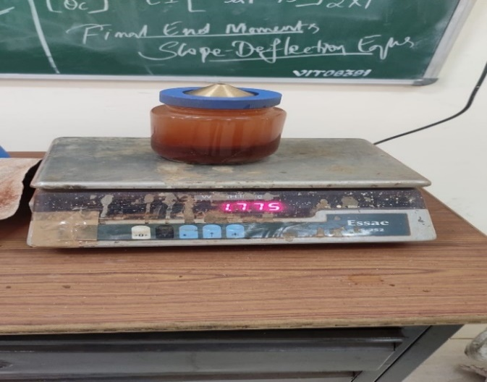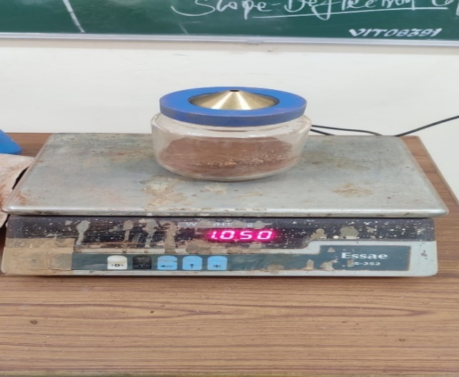Specific gravity is defined as the ratio of the weight of a given volume of waste brick powder to weight of an equal volume of water. The specific gravity shows the strength and quality of the material. waste brick powder with low specific gravity values indicates that it is having less strength.

**Fig 3.8: SPECIFIC GRAVITY OF BRICK POWDER**

**TABULAR COLUMN: -**

|  |  |  |  |  |
| --- | --- | --- | --- | --- |
| **SI no** | **Weight (gm)** | **Trial 1** | **Trial 2** | **Trial 3** |
| **1** | Weight of empty  Pycnometer(W1) | 659 | 659 | 659 |
| **2** | Weight of empty  Pycnometer + BP (W2) | 1050 | 1055 | 1041 |
| **3** | Weight of empty  Pycnometer + BP + water (W3) | 1775 | 1781 | 1780 |
| **4** | Weight of empty  Pycnometer + water (W4) | 1541 | 1541 | 1541 |
| **5** | Specific gravity | 2.64 | 2.53 | 2.67 |

**FORMULA: -**

Specific gravity = (W2-W1)/(W2-W1) -(W3-W4)

= (1050-659) / (1050-659) – (1780-1541)

= 2.67

**RESULT: -** The Specific Gravity of Brick Powder is **2.67**

**COMPARISION**

|  |  |  |
| --- | --- | --- |
| **Tests on Materials** | **Results obtained** | **Standard values as per IS** |
| **1. Cement**: |  |  |
| * Normal consistency | 32% | 31%-35% |
| * Specific gravity | 3.16 | 3.16 |
|  |  |  |
| **2. Coarse Aggregate**: |  |  |
| * Gradation of CA | 7.1 | <30% |
| * Specific Gravity | 0.62 | 0.1 – 2% |
|  |  |  |
| **3. Fine Aggregate**: |  |  |
| * Gradation of FA | 2.75 | 2.65-2.67 |
| * Specific Gravity | 2.71 | 2.6-2.8 |
| * Bulking of fine aggregate | 46% | 5-8% |
|  |  |  |
| **4 Brick powder** |  |  |
| * Gradation of BP | 2.4 | 2.6 |
| * Specific Gravity | 2.67 | 2.6-2.8 |

* **TESTS CONDUCTED ON FRESH CONCRETE**

1. Slump cone test
2. Compaction factor test

* **SLUMP CONE TEST**

Slump valve gives the measure of workability of concrete. In this test fresh concrete is filled into a mould of specified shape and dimensions, and the settlement or slump is measured when supporting mould is removed. Slump increases as water-content is increased. For different works different slump values have been recommended. By this test one can determine the water content to give specified slump value.

**TEST STANDARD REFERENCE**:

Test for Workability - Slump Test as per IS: 1199 1959, Methods of Sampling and Analysis of Concrete.

**OBSERVATION:**

Height of slump cone: - 300 mm

Top Dia. of cone: - D1= 100mm, R1 = 50mm

Bottom Dia. of cone: - D2=200mm, R2 = 100mm

**CALCULATION:**

Volume = 1/3(R12+R22+R1*R2) H*3.14

= 1/3(502+1002+(50*100)) * 300*3.14

= 5.265 x10^3 cm3

|  |  |  |  |  |  |
| --- | --- | --- | --- | --- | --- |
| **SL NO** | **WATER CEMENT RATIO** | **Water added in ml** | **H1 in mm** | **H2 in mm** | **Slump (H1-H2) in mm** |
| **01** | **0.6** | **1116** | **300** | **200** | **100** |

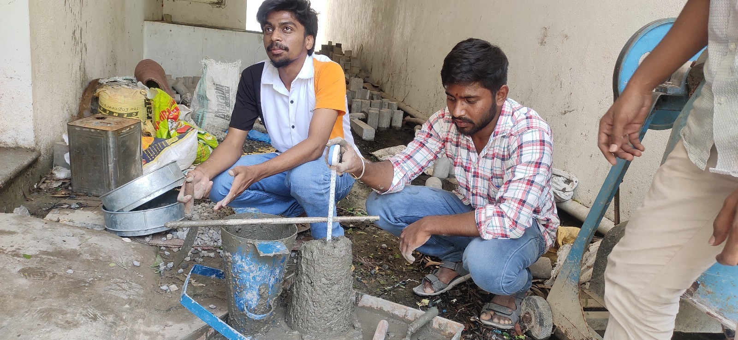**TABULAR COLUMN: -**

**Fig 3.9 SLUMP CONE**

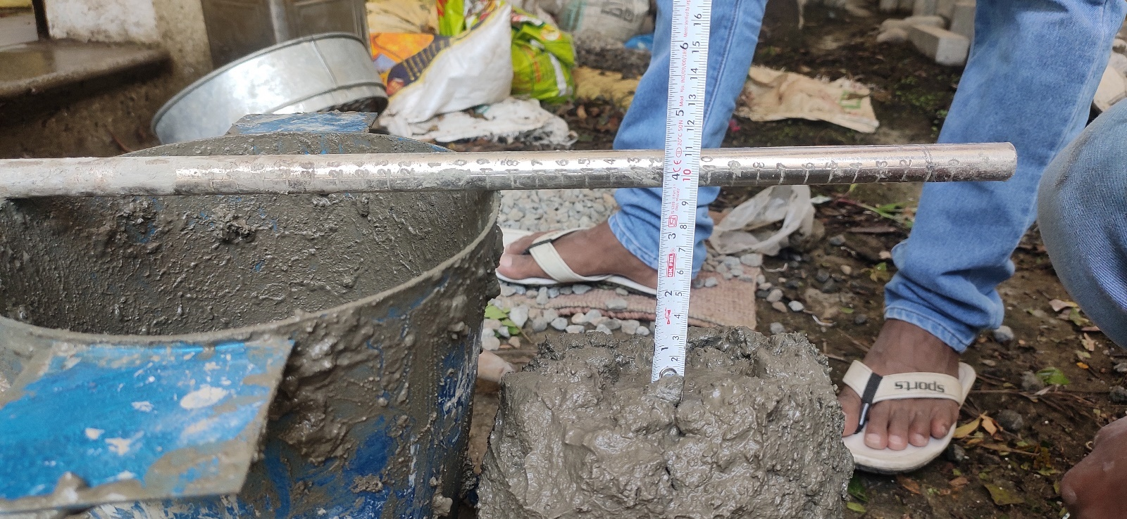**3.9.1 100mm SLUMP CONE**

**RESULT:** -

The Height of the Slump Cone = **100mm**

* **COMPACTION FACTOR TEST: -**

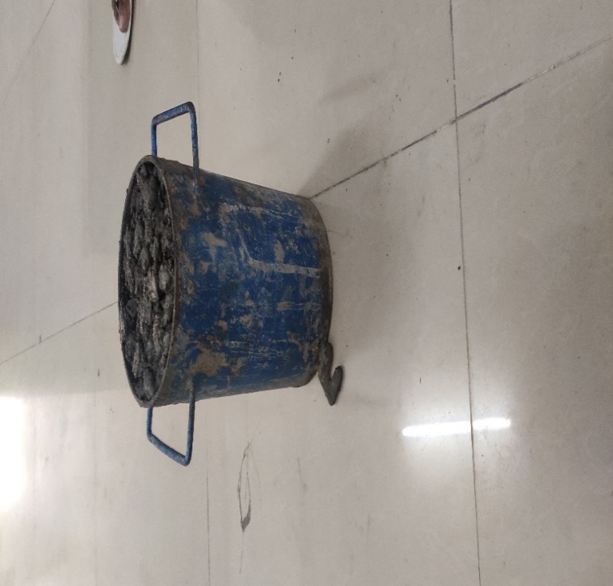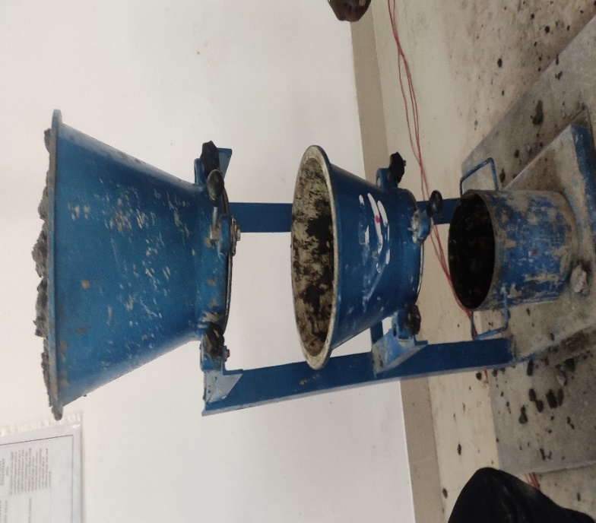It is the workability test for concrete in laboratory. The compaction factor is the ratio of weight of partially compacted to fully compacted concrete. it is used to determine workability of concrete.it ranges from 7.0 to 9.5.

**Fig 3.10: COMPACTION FACTOR TEST**

**OBSERVATION: -**

Height of cylinder = 30 cm

Dia. of cylinder = 15 cm

Empty weight of cylinder = 1.34 kg

**Calculation: -**

Volume = (3.14*d2)/4 * H = (3.14*152)/4 * 300

= 4.8596 X 10^3

Compacted by Land weight = 17.268 kg

Compacted by Machine = 16.2 kg

Compaction factor = 16.2/17.268 = 0.92 x 100

= 9.2

**RESULT: -** The Compaction Factor of the concrete **= 9.2**

**TESTS CONDUCTED ON HARDEN CONCRETE**

1. Compressive strength test.
2. Flexural tensile test.
3. Split tensile test.
4. **COMPRESSIVE STRENGTH TEST: -**

Compressive strength is the ability of material or structure to carry the loads on its surface without any crack or deflection. A material under compression tends to reduce the size, while in tension, size elongates.

* **COMPRESSIVE STRENGTH FORMULA**

Compressive strength formula for any material is the load applied at the point of failure to the cross-section area of the face on which load was applied.

**Compressive Strength = Load / Cross-sectional Area**

**PROCEDURE: COMPRESSIVE STRENGTH TEST OF CONCRETE CUBES**

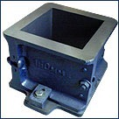

For cube test two types of specimens either cubes of 15cm X 15cm X 15cm or 10cm X 10cm x 10cm depending upon the size of aggregate are used. For most of the works cubical moulds of size 15cm x 15cm x 15cm are commonly used.

This concrete is poured in the mould and appropriately tempered so as not to have any voids. After 24 hours, moulds are removed, and test specimens are put in water for curing. The top surface of these specimen should be made even and smooth. This is done by placing cement paste and spreading smoothly on the whole area of the specimen.

These specimens are tested by compression testing machine after seven days curing or 28 days curing. Load should be applied gradually at the rate of 140 kg/cm2 per minute till the Specimens fails. Load at the failure divided by area of specimen gives the compressive strength of concrete.

* **CALCULATION OF MATERIALS FOR CUBE: -**

150mm X 150mm X 150mm

Volume of cube = 0.003375m3

Wet Volume = 1.54 X dry Volume

= 1.54 X 0.003375

= 0.005197m3

* **QUNATITY OF MATERIAL REQUIRED**

CUBE DIMENSION: 150X150mm

* OPC cement grade 53 =1.70kg.
* Fine aggregate = 1.10 kg.
* Coarse aggregate = 3.50kg.
* Waste brick powder = (15% of 1.10) = 0.935kg

= (25% of 1.10) = 0.825kg

= (30% of 1.10) = 0.770kg

= (40% of 1.10) = 0.660kg

= (50% of 1.10) = 0.550kg

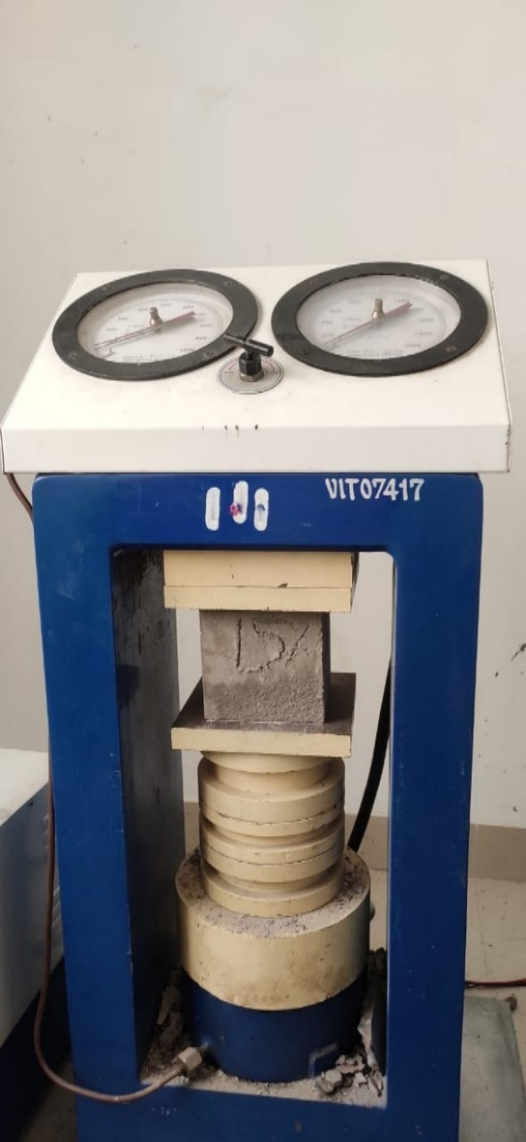

**Fig 3.11 COMPRESSIVE TEST**

**TABULAR COLUMN; -**

|  |  |  |  |  |
| --- | --- | --- | --- | --- |
| **SI NO.** | **CUBE**  **DESIGNATION** | **AREA IN mm2** | **LOAD IN KN** | **COMPRESSIVE STRENGTH (P/A) IN N/mm2** |
| **01** | **7 DAYS CURING** |  |  |  |
|  | 0% | 22500 | 510 | 22.06 |
|  | 15% | 22500 | 520 | 23.11 |
|  | 25% | 22500 | 490 | 21.77 |
|  | 30% | 22500 | 460 | 20.44 |
|  | 40% | 22500 | 420 | 18.66 |
|  | 50% | 22500 | 360 | 16 |
| **02** | **14 DAYS CURRING** |  |  |  |
|  | 0% | 22500 | 580 | 25.77 |
|  | 15% | 22500 | 630 | 28 |
|  | 25% | 22500 | 610 | 27.1 |
|  | 30% | 22500 | 580 | 25.7 |
|  | 40% | 22500 | 540 | 24 |
|  | 50% | 22500 | 460 | 20.4 |
| **03** | **28 DAYS CURRING** |  |  |  |
|  | 0% | 22500 | 630 | 28 |
|  | 15% | 22500 | 650 | 28.88 |
|  | 25% | 22500 | 620 | 27.55 |
|  | 30% | 22500 | 580 | 25.77 |
|  | 40% | 22500 | 560 | 24.88 |
|  | 50% | 22500 | 510 | 22.66 |
|  |  |  |  |  |
|  |  |  |  |  |

1. **7 DAYS CURING COMPRESSIVE STRENGTH**
2. **14 DAYS CURING COMPRESSIVE STRENGTH**
3. **28 DAYS CURING COMPRESSIVE STRENGTH**
4. **FLEXURAL TENSILE TEST: -**

Flexural test evaluates the tensile strength of concrete indirectly. It tests the ability of unreinforced concrete beam or slab to withstand failure in bending. The results of flexural test on concrete expressed as a modulus of rupture which denotes as (*MR*) in MPa or psi.

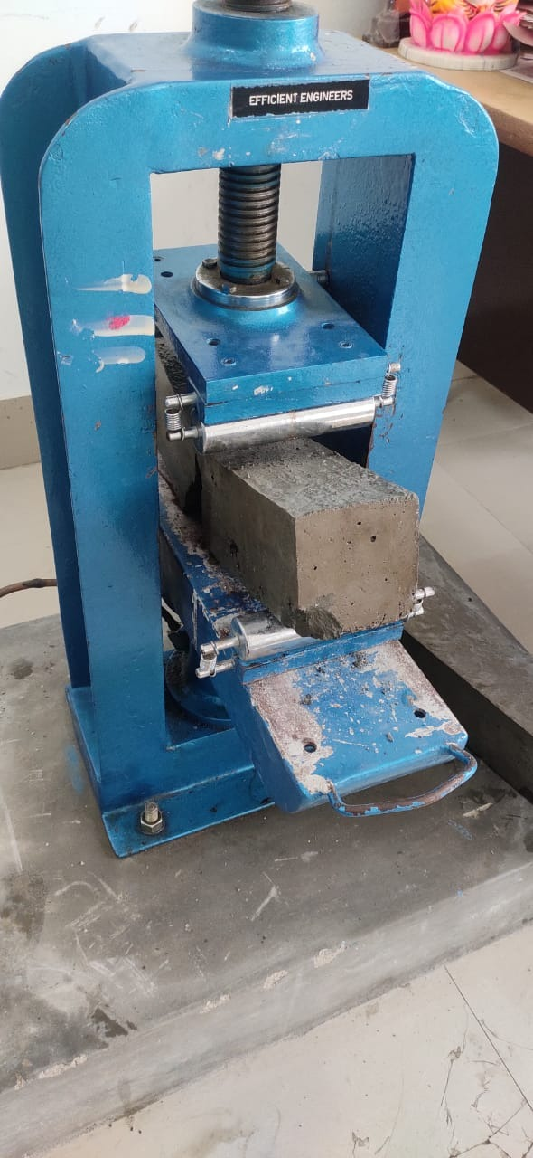

**Fig 3.12: FLEXURE TEST**

**TABULAR COLUMN: -**

|  |  |  |  |  |  |
| --- | --- | --- | --- | --- | --- |
| **Sl. No.** | **Mark of beam/beam designation** | **Date of casting** | **Date of testing** | **Load (P) in**  **KN** | **Flexural**  **Strength**  **N/mm2** |
| **1** | **7DAYS**  **CURING** |  |  |  |  |
|  | **0%** | **7/06/2022** | **17/06/2022** | **11** | **2.42** |
|  | **15%** | **7/06/2022** | **17/06/2022** | **12** | **2.76** |
|  | **25%** | **7/06/2022** | **17/06/2022** | **10** | **2.3** |
|  | **30%** | **7/06/2022** | **17/06/2022** | **11** | **2.69** |
|  | **40%** | **7/06/2022** | **17/06/2022** | **10** | **2.11** |
|  | **50%** | **7/06/2022** | **17/06/2022** | **09** | **1.8** |
| **2** | **28DAYS**  **CURING** |  |  |  |  |
|  | **0%** | **09/06/2022** | **12/07/2022** | **15** | **3.6** |
|  | **15%** | **09/06/2022** | **12/07/2022** | **16** | **3.52** |
|  | **25%** | **09/06/2022** | **12/07/2022** | **14** | **3.36** |
|  | **30%** | **09/06/2022** | **12/07/2022** | **13** | **2.86** |
|  | **40%** | **09/06/2022** | **12/07/2022** | **11** | **2.42** |
|  | **50%** | **09/06/2022** | **12/07/2022** | **10** | **2.20** |

**BAR CHART:**

**BAR CHART OF FLEXURAL STRENGTH 7 DAYS**

**BAR CHART OF FLEXURAL STRENGTH 28 DAYS**

1. **SPLIT TENSILE TEST; -**

Splitting tensile strength test on concrete cylinder is a**technique to resolve the tensile strength of concrete.** The concrete is very fragile in stress because of its fragile character and is not anticipated to oppose the direct tension. The concrete therefore gets splits and cracks when they are exposed to tensile forces.

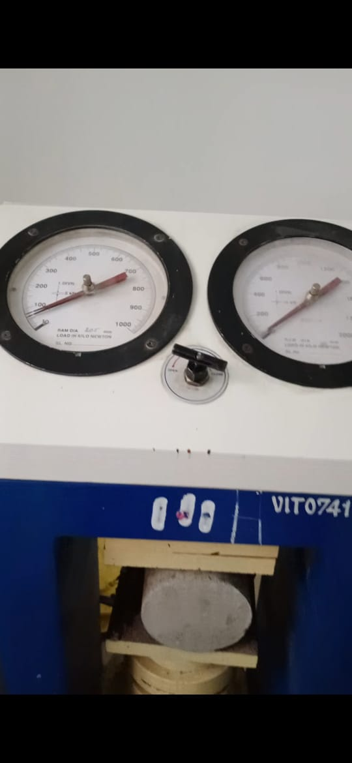

**Fig 3.13: SPLIT TENSILE TEST**

**TABULAR COLUMN: -**

|  |  |  |  |
| --- | --- | --- | --- |
| **SI NO** | **REPLACEMENT** | **LOAD**  **KN** | **SPLIT TENSILE STRENGHT N/mm2** |
| **01** | **7 DAYS** |  |  |
|  | 0% | 110 | 1.56 |
|  | 15% | 120 | 1.70 |
|  | 25% | 100 | 1.41 |
|  | 30% | 90 | 1.27 |
|  | 40% | 80 | 1.2 |
|  | 50% | 50 | 0.8 |
| **02** | **28 DAYS CURING** |  |  |
|  | 0% | 200 | 2.83 |
|  | 15% | 230 | 3.25 |
|  | 25% | 210 | 2.97 |
|  | 30% | 190 | 2.69 |
|  | 40% | 160 | 2.26 |
|  | 50% | 140 | 2.0 |

**BAR CHART: 7 DAYS**

**BAR CHART: 28 DAYS**

**CONCLUSION**

Based on the literature, brick debris or construction waste can be used as partial replacement of fine aggregate. We get a lot of waste material from the demolition site causing environmental pollution that construction waste can as partial replacement to fine aggregate or coarse aggregate.

We can get environmentally friendly mortar and concrete by partial replacement of fine aggregate with waste brick powder from demolished structures can be consumed by this method without causing the environmental problems.

As per literature, results indicate that there is a strength enhancement at 15% replacement of fine aggregate with brick debris. Therefore, we can say that 15% is the optimum replacement that can be achieved compared to conventional mortar and concrete. Based on the experimental study of investigating the use of waste brick powder in concrete, the following conclusions which are limited to the materials used in the study.

• This is an eco-friendly concrete as it subsides the stagnation of demolished brick waste by consuming it.

• As much as of the total cost of fine aggregate in conventional method can be saved by this procedure.

• The test results of compressive strength show that the optimum replacement of fine aggregate is achieved at 15% replacement of fine aggregate by crushed brick debris compared to the respective conventional concrete strength.

• The possibility exists for the partial replacement of fine aggregate with brick debris which is produced during demolition of construction site.

## REFERENCES

1. **K. Muthusamy, A. M. A. Budiea, S. M. Syed Mohsin et al.,** *Properties of fly ash cement brick containing palm oil clinker as fine aggregate replacement,* Materials Today: Proceedings, <https://doi.org/10.1016/j.matpr.2020.07.260>
2. **S. Rahul D, S. Vikas Reddy, T. N et al.,** *Influence of brick waste and brick waste fines as fine aggregate on the properties of paver blocks* – Preliminary investigation, Proceedings, <https://doi.org/10.1016/j.matpr.2020.09.310>

1. **[JuntaoDang](https://www.sciencedirect.com/science/article/pii/S0950061820320377?via%3Dihub" \l "!)[ad](https://www.sciencedirect.com/science/article/pii/S0950061820320377?via%3Dihub" \l "!)****[,](https://www.sciencedirect.com/science/article/pii/S0950061820320377?via%3Dihub" \l "!)****[Sze DaiPang](https://www.sciencedirect.com/science/article/pii/S0950061820320377?via%3Dihub" \l "!)[c](https://www.sciencedirect.com/science/article/pii/S0950061820320377?via%3Dihub" \l "!)et al.,** *Durability and micro structural properties of concrete with recycled brick as fine aggregate* – Preliminary investigation, Proceedings, <https://doi.org/10.1016/j.conbuildmat.2020.120032>
2. **Imane Rainia, Raouf Jabrane, et al.,** *Evaluation of mortar properties by combining concrete and brick wastes as fine aggregate* – Preliminary investigation, Proceedings, <https://doi.org/10.1016/j.cscm.2020.e00434>
3. **Manoj Kumar, Awadhesh Chandramauli, et al.,** *Partial Replacement of Fine Aggregates of Fire Bricks with Fine Aggregates in Concrete,* International Journal of Civil Engineering and Technology, 9(3), 2018, pp. 961–968. <http://iaeme.com/Home/issue/IJCIET?Volume=9&Issue=3>
4. **Qian Huang a, Xiaohong Zhu et al,,** *Recycling of crushed waste clay brick as aggregates in cement mortars:* An approach from macro- and micro-scale investigation, [https://doi.org/10.1016/j.conbuildmat.2020.122068 0950-0618](https://doi.org/10.1016/j.conbuildmat.2020.122068%200950-0618) 2020 Elsevier Ltd. All rights reserved.
5. **Arivalagan. S Et al.,** *Feasible and Experimental Study on Partial Replacement of Fine Aggregate using Construction Debris* <http://dx.doi.org/10.20902/IJCTR.2019.130206>
6. **Diniya David, et al.,** *Partial Replacement of Fine Aggregate with Crushed Clay Brick in Cellular Concrete.* International Journal of Research in Engineering and Technology. DOI:10.15680/IJIRSET.2017.0605161
7. **M. Lakshmi, and S. Nivedhitha,** *“Effect of partial replacement of aggregates by recycled concrete debris on strength of concrete”,* Malaysian Journal of Civil Engineering, Vol. 27(2), pp 250-259, 2015.
8. **M. Nili, N. Biglarijoo, and S.A. Mirbagheri,** “*A Review on the Use of Various Kinds of Debris and Demolitions in Concrete and Mortar Mixes”,* 10th International Congress on Advances in Civil Engineering, Middle East Technical University, Ankara, Turkey, 17-19 October 2012.
9. **D. Kumar, G. Mohiuddin, and M. A. Haleem**, *“An experimental study on partial replacement fine aggregate with coal bottom ash in concrete”*, International Journal of Research Sciences and Advanced Engineering, Vol. 2(15), pp 39-49, 2016.
10. **Sai Samanth, and A. Prakhar,** “*Study of strength properties of concrete with construction debris as aggregates*”, International Journal of Engineering Research in Mechanical and Civil Engineering, Vol. 1(5), pp 42-45, 2016
11. **A. Shayan and A. Xu*,*** *“Value added utilization of waste glass in concrete”,* Cement and Concrete Research, vol-44, pp.81-89, Jan.2004.
12. **Shriharsha, Murthy S.N.** *Alternative building materials using fine ground granulated blast furnace slag and fine demolition debris*. International Journal of Renewable Energy and Environmental Engineering. 2(2), 2014, pp 86-88.
13. **IS 383-1970:** Indian Standard specifications for coarse and fine aggregate. Bureau of Indian standards.
14. **IS 456-2000:** Code of Practice for Plain and Reinforced Concrete. Bureau of Indian standards.
15. **IS 10262-2209:** Recommended guidelines for Mix Concrete. Bureau of Indian standards.
16. **IS 2386-1963** Methods of test for aggregate for concrete. Bureau of Indian standards.